

MAGNA COLLEGE OF ARTS AND SCIENCE

REDHILLS-TIRUVALLUR HIGH ROAD,MAGARAL,CHENNAI

DEPARTMENT OF COMPUTER APPLICATIONS

TAMILNADU SKILLS-PROJECT

EDUGENIE: GOOGLE GEMINI POWERD LEARNING ASSISTANT

SANTHOSHNI P - 212506737

HEMANATH S -212506720

ZAHEER S -212506730

NAVEEN KUMAR S -212506723

VIJAYALAKSHMI M -212506738

BATCH 2025-2028

EDU GENIE – AI LEARNING ASSISTANT

PROJECT DOCUMENTATION

1. ABSTRACT
EduGenie is an AI-based learning assistant designed to provide students with a simple and interactive digital learning environment. The system helps students learn, clarify doubts, practice questions, and access study materials through a single web application.
The application consists of different modules such as Home, AI Tutor, Quiz, and Notes. The AI Tutor helps students ask questions and receive explanations. The Quiz module allows students to test their knowledge through multiple-choice questions. The Notes section provides useful study materials for revision.
The project can be developed using HTML, CSS, and JavaScript, with an AI service such as the Google Gemini API integrated for AI-powered responses. EduGenie aims to make learning more convenient, interactive, and student-friendly.

2. INTRODUCTION
Education is becoming increasingly digital, and students have access to many online learning resources. However, students may still find it difficult to get quick explanations, practice questions, and study materials in one place.
EduGenie provides a simple solution by combining learning assistance, quizzes, and notes into a single platform.
The system provides a user-friendly interface where students can navigate between different learning features. The AI Tutor can assist with questions, while quizzes help students test their understanding and notes support revision.

3. PROBLEM STATEMENT
Students often use different platforms for asking doubts, studying notes, and practicing questions. Switching between multiple applications can make learning less convenient.
The problem addressed by EduGenie is the lack of a simple, unified learning platform that provides:
- AI-based learning assistance
- Practice quizzes
- Study notes
- Easy navigation
- Interactive learning support

4. EXISTING SYSTEM
In the existing learning system, students generally depend on:
- Textbooks
- Search engines
- Online educational websites
- Separate quiz applications
- Video-learning platforms
- Notes stored in different locations

Disadvantages of the Existing System
- Learning resources are distributed across different platforms.
- Students may spend more time searching for information.
- Separate applications may be required for different activities.
- Quick doubt clarification may not always be available.
- Study notes and quizzes may not be available together.

5. PROPOSED SYSTEM
EduGenie is proposed as a unified digital learning assistant.
The system provides multiple learning facilities in one application:
- AI Tutor
- Quiz
- Notes
- Student-friendly interface
The AI Tutor can use an AI service to understand student questions and generate educational responses. The Quiz module provides practice questions, while the Notes module provides study materials.

6. OBJECTIVES
The main objectives of EduGenie are:
- To develop a simple AI-powered learning assistant.
- To help students clarify their doubts.
- To provide interactive quizzes.
- To provide study notes in one platform.
- To make learning more engaging.
- To reduce the effort required to find learning resources.
- To provide a simple and user-friendly interface.
- To support students in self-learning and revision.

7. SCOPE OF THE PROJECT
EduGenie can be used as a basic educational platform for students.
The scope includes:
- AI-based question answering
- Programming learning
- Quiz-based practice
- Study notes
- Revision support
Interactive learning
The system can be expanded in the future to support additional subjects, student accounts, performance tracking, voice interaction, and personalized learning.

8. FEATURES

8.1 Home
The Home page introduces the EduGenie application.
It displays:
“Learn Smarter with EduGenie”
“Your simple digital learning assistant.”

8.2 AI Tutor
The AI Tutor allows students to enter questions and receive explanations.
Example:
Student Question:
What is encapsulation?
The AI Tutor can provide a simple explanation suitable for learning.

8.3 Quiz
The Quiz module provides multiple-choice questions.
Example:
Which of the following is a feature of Object-Oriented Programming?
A) Encapsulation
B) Compilation
C) Debugging
D) Formatting
The quiz can be extended to calculate scores and provide feedback.

8.4 Notes
The Notes module provides useful educational content for students.
It can contain:
- Important definitions
- Short notes
- Programming concepts
- Exam preparation materials
- Revision points

9. SYSTEM REQUIREMENTS

9.1 Hardware Requirements
- Computer or laptop
- Minimum 2 GB RAM
- Keyboard
- Mouse
- Internet connection for online AI functionality

9.2 Software Requirements
- Windows / Linux / macOS
- Google Chrome / Microsoft Edge / Firefox
- Visual Studio Code
- HTML
- CSS
- JavaScript
- AI API for AI-powered functionality

10. TECHNOLOGIES USED

HTML
HTML is used to create the structure of the EduGenie web application.

CSS
CSS is used to design the interface and provide styling.

JavaScript
JavaScript is used to implement interactive functionality such as navigation, quiz processing, and user interaction.

Google Gemini API
The Google Gemini API can be integrated to provide AI-powered responses through the AI Tutor module.

11. SYSTEM ARCHITECTURE
USER
|
↓
EDU GENIE
|
┌─────────────┼─────────────┐
↓ ↓ ↓
HOME AI TUTOR QUIZ
| |
↓ ↓
AI SERVICE QUESTIONS
| |
↓ ↓
RESPONSE RESULT

|
↓
NOTES

12. MODULE DESCRIPTION

Module 1 – Home Module
The Home module provides an introduction to EduGenie and links to the different features.

Module 2 – AI Tutor Module
The AI Tutor receives a student's question and provides an educational response using predefined logic or an AI API.

Module 3 – Quiz Module
The Quiz module displays questions and multiple-choice options. It can check answers and calculate the student's score.

Module 4 – Notes Module
The Notes module provides educational materials that students can use for learning and revision.

13. WORKING PRINCIPLE
The working process of EduGenie is:
- The student opens the EduGenie website.
- The Home page is displayed.
- The student selects a required feature.
- The student can ask a question through AI Tutor.
- The AI Tutor processes the question.
- The response is displayed to the student.
- The student can take a quiz.
- The student can access study notes.
- The student uses the application for learning and revision.

14. ALGORITHM

AI Tutor Algorithm
Step 1: Start
Step 2: Open AI Tutor
Step 3: Enter student question
Step 4: Check whether the question is empty
Step 5: If empty, display a message
Step 6: Otherwise process the question
Step 7: Generate or retrieve the answer
Step 8: Display the answer
Step 9: Stop

Quiz Algorithm
Step 1: Start
Step 2: Display quiz questions
Step 3: Display answer options
Step 4: Get student's answer
Step 5: Compare with correct answer
Step 6: Update score
Step 7: Continue until all questions are completed
Step 8: Display final result
Step 9: Stop

15. DATABASE
The basic version of EduGenie does not require a database.
Questions, quiz answers, and notes can be stored in JavaScript.
For an advanced version, a database can be used to store:
- Student information
- Quiz scores
- Question banks
- Notes
- Learning history
- User progress

16. USER INTERFACE
The main navigation of the application is:
🤖 EduGenie

Home AI Tutor Quiz Notes
The Home page displays:
Learn Smarter with EduGenie

Your simple digital learning assistant.
The footer displays:
© 2026 EduGenie | Student Learning Assistant

17. TESTING
Testing is performed to verify that the application works correctly.
Test Case | Input | Expected Result
Home Page | Open website | Home page displayed
Navigation | Click AI Tutor | AI Tutor opens
AI Tutor | Enter question | Response displayed
Quiz | Open Quiz | Questions displayed
Quiz Answer | Select option | Answer processed
Notes | Click Notes | Notes displayed
Empty Question | Submit empty input | Validation message displayed

18. ADVANTAGES
- Simple and easy to use.
- Student-friendly interface.
- Provides multiple learning features.
- Supports interactive learning.
- Helps students clarify doubts.
- Provides quiz-based practice.
- Provides study notes.
- Can be expanded with AI features.

19. LIMITATIONS
- AI responses depend on the configured AI service.
- Internet access may be required for API-based AI functionality.
- The basic version may contain a limited number of questions and notes.
- AI-generated information should be checked with reliable educational sources.

20. FUTURE ENHANCEMENTS
Future versions can include:
- Google Gemini API integration.
- Voice-based AI Tutor.
- AI-generated quizzes.
- Automatic question generation.
- Student login and registration.
- Database integration.
- Quiz score history.
- Student performance analysis.
- Personalized learning recommendations.
- Multiple-language support.
- Mobile application.
- Progress dashboard.

21. APPLICATIONS
EduGenie can be used for:
- College students
- School students
- Programming practice
- Exam preparation
- Self-learning
- Classroom activities
- Quick revision
- Doubt clarification

22. PROJECT STRUCTURE
EduGenie/
│
├── index.html
├── style.css
├── script.js
├── README.md
│
└── assets/
├── images/
└── icons/

23. EXPECTED OUTPUT
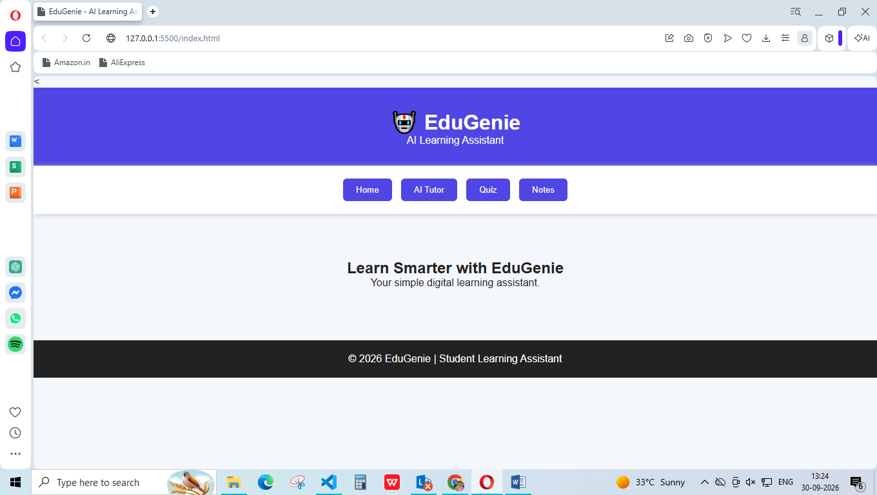

24. SECURITY AND RESPONSIBLE USE
EduGenie should be designed to protect user information and use AI responsibly.
Important considerations include:
- Do not collect unnecessary personal information.
- Protect API keys and credentials.
- Validate user inputs.
- Use secure API communication.
- Encourage students to verify important information.
- AI should support learning rather than replace independent thinking.

25. CONCLUSION
EduGenie – AI Learning Assistant is a student-focused web application that combines AI-based learning assistance, quizzes, and study notes in one platform.
The project demonstrates how HTML, CSS, JavaScript, and AI technology can be combined to create an interactive educational application.
EduGenie provides a simple environment where students can ask questions, practice through quizzes, and revise using notes. The project can be further enhanced with AI-powered features, databases, personalized learning, voice interaction, and performance tracking.

26. REFERENCES
- MDN Web Docs – https://developer.mozilla.org/
- GitHub Documentation – https://docs.github.com/
- Google Gemini API Documentation – https://ai.google.dev/
- HTML Documentation – https://developer.mozilla.org/en-US/docs/Web/HTML
- JavaScript Documentation – https://developer.mozilla.org/en-US/docs/Web/JavaScript

27. PROJECT DETAILS
Project Name: EduGenie – AI Learning Assistant
Project Type: Educational Web Application
Technologies: HTML, CSS, JavaScript
Main Modules: Home, AI Tutor, Quiz, Notes
Target Users: Students
Purpose: AI-assisted learning, practice, and revision
Year: 2026

